Your goal is to create two lists of words and connect them together so you may translate from one language to another. Create one list in English and one in another language of your choice. Then, write a program that will ask the user to enter a word in one of the languages. The program will respond by printing the word in the other language. Please refrain from using pictograms … do your best with English phonetic spelling.

Let's say I want to create an English <--> French translator. Here's a table containing my English words and the French words they translate to …

|  |  |
| --- | --- |
| English | French |
| chicken | poulet |
| salt | sel |
| apple | pomme |
| earth | terre |
| bean | haricot |
| water | eau |
| milk | lait |

… you ought to have at least six words to translate. Now make one list for each language …

**english = ['chicken','salt','apple', …]**

**french = ['poulet','sel','pomme', …]**

Once you have found the index of a word in one list, you can use that index in the other list to translate the word into the other language … there’s a method for finding the index of a list member … **index()**

Step-by-step

1. Prompt the user for a word (it's best to also convert it to lower case), then test
2. Check if the word is in the english list, then test
3. If the word is English compute the index (**english.index(word)**), then test
   1. Use the index to find the corresponding word in the french list (**french[english_index]**)
   2. Print the translation, test here
4. Otherwise, check if the word is in the french list and repeat (3) above by computing the index in the french list, looking it up in the english list and printing the result
5. Otherwise, if the word is in neither list, print a message saying the word could not be found.

Examples …

**French word as input …**

Machine generated alternative text:
Program to translate words from Engilsh to French and vice—versa 
Enter an English or French word to translate: pomme 
The French word 'pommel is 'apple' in English 

**English word as input …**

Machine generated alternative text:
Program to translate words from Engilsh to French and vice—versa 
Enter an English or French word to translate: WATER 
The English word 'water' is 'eau' in French 

**Unknown word as input …**

Machine generated alternative text:
Program to translate words from Engilsh to French and vice—versa 
Enter an English or French word to translate: turkey 
The word 'turkey' was not found in English or French word lists 

**NOW, ENHANCE THE PROGRAM**

If an unknown word is input, the program could ask if the user would like to add the word to the dictionary. If the user answers yes, the program asks if the language of the unknown word is English or French and then asks for the translation. Both words are added to the respective lists and the program goes back to prompting the user for a word.

To add this enhancement, the program must run in a continuous loop (**while True:**) because once the program exits, any words added to the lists will be lost. So then, you need to think about when to exit. That's pretty easy … **break** if the input string is null.

IMPORTANT: When you enclose the interactive part of your program in a loop, it's important to separate the initialization of any list variables from the loop. For example, if you've just gone through the process of adding new words to the dictionary, the last thing you want to do is go back and initialize the dictionary again because this will remove anything you've added. Also, you ought to make everything case insensitive by converting all inputs to lower case.

**NEXT STEPS**

Over the next couple of weeks, we will continue to develop this program in several ways. First, the program has no way to permanently save the words you add. So, when you exit the program, you lose the changes you made. We will address this issue when we start working with data files. Second, a dictionary seems like the best data structure to use here. But as things get more complex, there are always trade-offs to consider. Lists are simple and two lists provide a way that establishes the connection without any duplication. Next week, when we expand this program, you will want to have two dictionaries … one with English keys and one with French (or other language) keys.

Here are some extended examples of what you ought to be able to achieve in the language of your choice using lists initially and then moving to creating dictionaries (next week) from the lists and using the dictionaries for translation …

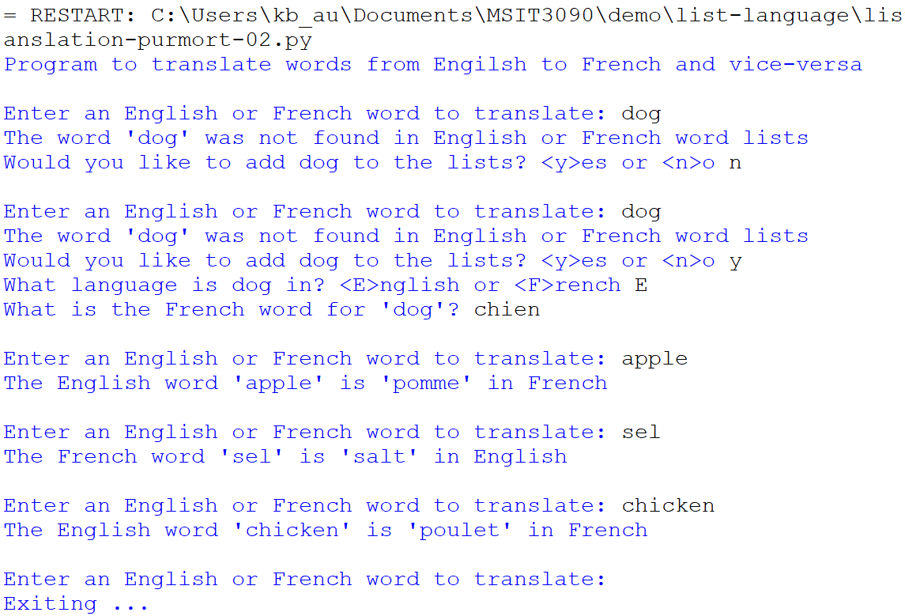

 The program exits when a null string is entered.

Another example ...

Machine generated alternative text:
Program to translate words from Engilsh to French and vice—versa 
Enter an English 
The English word 
Enter an English 
The French word 
Enter an English 
The French word 
Enter an English 
or French word to translate: apple 
apple' is 'pornme' in French 
or French word to translate: eau 
' eau' is 'water' in English 
or French word to translate: haricot 
'haricot' is 'bean' in English 
or French word to translate: red 
The word ' red' was not found in English or French word lists 
Would you like to add red to the lists? <y>es or <n>o y 
What language is red in? <E>ng1ish or <F>rench e 
What is the French word for ' red'? rouge 
Enter an English or French word to translate : 
The French word rouge' is red' in English 
Enter an English or French word to translate: 
The English word ' red' is ' rouge' in French 
Enter an English or French word to translate : 
rouge 
red 
bleu 
The word 'bleu' was not found in English or French word lists 
Would you like to add bleu to the lists? <y>es or <n>o y 
What language is bleu in? <E>ng1ish or <F>rench f 
What is the English word for 'bleu'? blue 
Enter an English or French word to translate: earth 
The English word 'earth' is 'terre' in French 
Enter an 
Exiting 
English or French word to translate: 